Project 1: Explore Weather Trends

**Steps Followed:**

1. Wrote a SQL query to get the data needed to complete the analysis. A subquery was utilized to extract the data for Riyadh, Saudi Arabia out of the city_data relation. Then, a join with the global_data relation on the year was performed. The produced table contained: year, average temperature in Riyadh, and average temperature globally. Finally, the data was imported to my local drive as a CSV file.
   1. The SQL query was as follows:
   2. 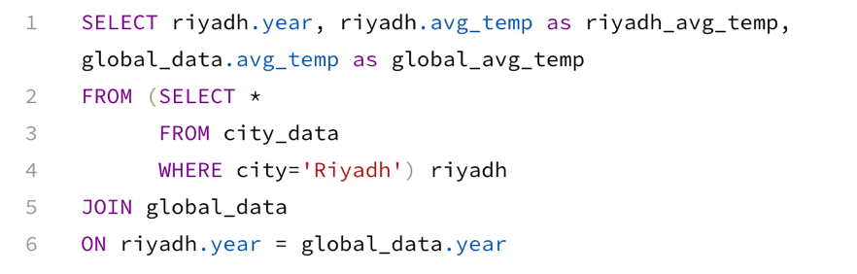
2. I utilized Python to complete this project (with the libraries: Pandas, Matplotlib, and Seaborn). The data was read in using Pandas, then the running average of both the Riyadh average temperature and the global average temperature was calculated using the function: Pandas.Series.rolling(window=7).mean().
3. Finally, the plot was produced using Matplotlib using subplots. The plots were laid out vertically to make analysis of the trend easier. Additionally, having two separate plots was superior to superimposing the two lines in one plot because it avoids the overlap of lines, which makes analysis difficult.

**Line Chart:**

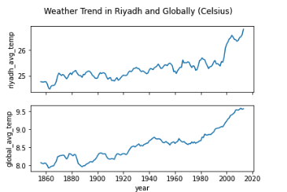

**Observations:**

* Riyadh is hotter than the global average.
* The average temperature trend in Riyadh is more volatile than that of the world.
* The weather is getting warmer both in Riyadh and globally.
* The rate of change is highest and most consistent between 2000 and 2018, both in Riyadh and globally.
* Riyadh is getting hotter faster than the globe average (the rate of change is higher) between 2000 and 2018.